
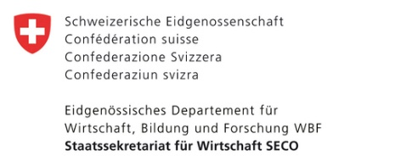

INVITATION TO TENDER
KURP 20(b) " Pedestrian Bridge Construction in Khorog, Tajikistan"

The Branch of “Aga Khan Agency for Habitat” (AKAH) in Tajikistan is pleased to invite all interested qualified companies to participate in the tender for the construction of the pedestrian bridge with a location in Khorog, Tajikistan under the framework of the Khorog Urban Resilience Programme (KURP).

The Khorog Urban Resilience Programme (KURP) is a five-year planning and proof of concept initiative designed to set up the structures, systems and capacity to transform Khorog into a model resilient city, promoting sustainable economic growth and investment. The programme links the Government of Tajikistan’s structures, planning and investments to initiatives by the community and national and international partners to build resilience and plan for opportunities for Khorog. Funding is provided by the Economic Cooperation and Development Division of the Swiss State Secretariat for Economic Affairs (SECO), with co-funding from the Aga Khan Development Network agencies.

- All tenders must be accompanied by a Tender Security of US Dollars 15,000.00 (Fifteen Thousand US Dollars).

- All sealed envelopes containing the bid documents must be delivered to the following addresses, not later than 10:00 on Friday, January 10 , 2025:
- 10th Floor, Tcell Plaza, 732000, Rudaki ave.34 Dushanbe, Tajikistan
- Zamirov st.5, Khorog, GBAO, Tajikistan

- The tender opening ceremony will take place at the office in Dushanbe, while other offices will be connected remotely.

- Key milestones:
- Announcement date – 9/12/2024
- Opening date of tender offers – 10/01/2025
- Post Bid Meeting and Clarifications with high scored companies based on technical and commercial criteria-TBC
- Final and best offer-TBC
- Company award-TBC

- In case of any clarification required, please contact us by this
e-mail: akahtjk.procurement@akdn.org not later than 14:00 on January 7, 2025.

For a complete package of tender documents, please follow the below link: www.akahdocs.tj
(Folder name: KURP 20(b) " Pedestrian Bridge Construction in Khorog, Tajikistan")


or scan the QR code:

